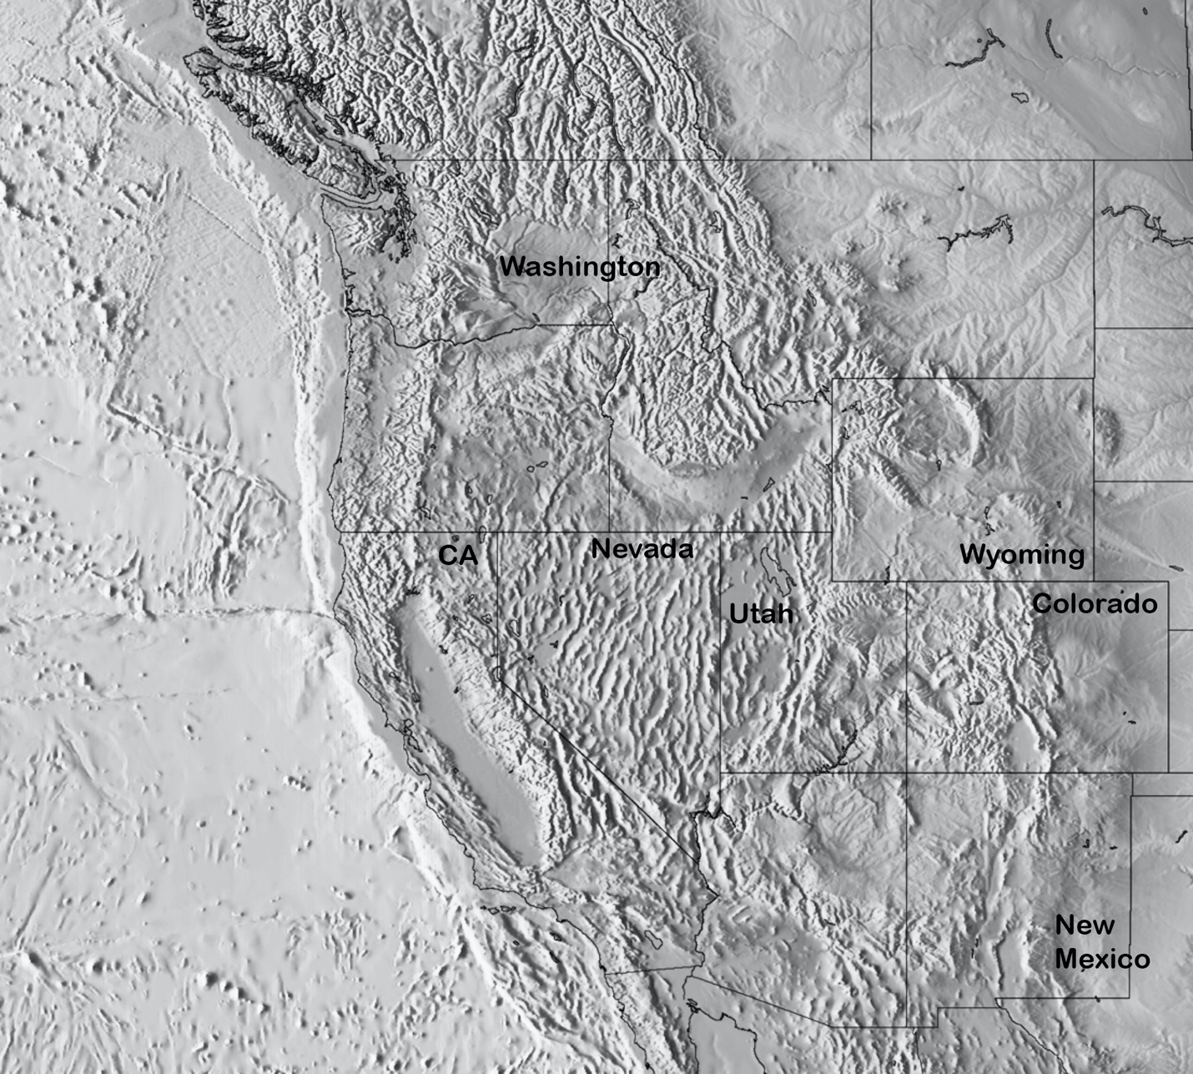

**Cordilleran Features:**

Circle and label. DO NOT NUMBER. YOU CAN WRITE ACRONYMS but do not number or color code.

Mendocino Triple Junction

Rocky Mountains (Colorado and Canadian)

Colorado Plateau

Basin and Range

Death Valley

San Anderas Fault

Central Valley (aka Great Valley)

Sierra Nevada

Yellowstone Hotspot

Snake River Plain

Cascade Range

Grand Canyon

Uinta Mountains

Juan de Fuca Ridge

Rio Grande Rift

Coast Ranges

Lake Bonneville

Pacific Plate

North American Plate